Thesis for the Degree of Master of Computer Information System

**Nepali Text Part Of Speech Tagging Using Different Deep Learning Algorithms**

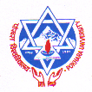

**Tika Ram Khojwar**

**(2020-2-92-0018)**

**Nepal College of Information Technology**

**Faculty of Management Studies**

**Pokhara University, Nepal**

**May, 2023**